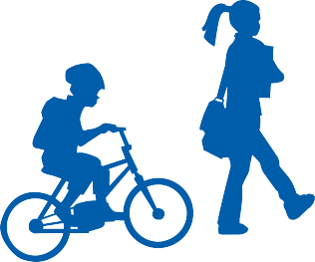
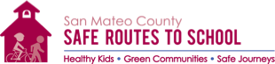

INTERNATIONAL WALK TO SCHOOL DAY
Wednesday, October 4, 2017!
Please join the fun and get moving on International Walk to School Day at Burlingame Intermediate. Our school will be participating in walking and biking to school on October 4, 2017. Please grab your friends and family for a healthy walk to school. Don’t forget to put a sticker on the Walking Banner when you arrive.

Please visit our Dsitict’s Safe Routes to School webpage for more information:
http://www.bsd.k12.ca.us/SafeRoutes

Safe Routes to School is a program that gets more kids and parents walking and biking to/from school. The program's aim is to create safe walking and biking conditions. Get started with a healthy, stress-free commute by participating in the International Walk to School Day.

